Cam 11 – Test 4
I. VOCABULARY
No. | Vocabulary | Phonetic | POS | Meaning
1 | twin | /twɪn/ | n. | anh/chị/em song sinh
2 | biomedical | /ˌbaɪ.oʊˈmed.ɪ.kəl/ | adj. | liên quan đến y sinh học
3 | researcher | /rɪˈsɜːrtʃər/ | n. | nhà nghiên cứu
4 | untangle | /ʌnˈtæŋ.ɡəl/ | v. | gỡ rối, làm sáng tỏ
5 | influence | /ˈɪn.flu.əns/ | n./v. | sự ảnh hưởng / ảnh hưởng
6 | gene | /dʒiːn/ | n. | gen
7 | nature | /ˈneɪ.tʃər/ | n. | yếu tố bẩm sinh, di truyền
8 | nurture | /ˈnɜːr.tʃər/ | n. | sự nuôi dưỡng, môi trường tác động
9 | identical twin | /aɪˈden.tɪ.kəl twɪn/ | n. | sinh đôi cùng trứng
10 | fertilize | /ˈfɜːr.t̬əl.aɪz/ | v. | thụ tinh
11 | split into | /splɪt ˈɪn.tuː/ | v. phr. | tách thành
12 | virtually | /ˈvɜːr.tʃu.ə.li/ | adv. | hầu như, gần như hoàn toàn
13 | fraternal | /frəˈtɜːr.nəl/ | adj. | sinh đôi khác trứng
14 | quantify | /ˈkwɑːn.t̬ə.faɪ/ | v. | định lượng, đo lường
15 | ailment | /ˈeɪl.mənt/ | n. | bệnh, chứng bệnh (không nghiêm trọng)
16 | vulnerability | /ˌvʌl.nər.əˈbɪl.ə.t̬i/ | n. | sự dễ bị tổn thương / dễ mắc bệnh
17 | root | /ruːt/ | v./n. | bắt nguồn / gốc rễ
18 | heredity | /həˈred.ə.t̬i/ | n. | sự di truyền
19 | pinpoint | /ˈpɪn.pɔɪnt/ | v. | xác định chính xác
20 | inheritance | /ɪnˈher.ɪ.təns/ | n. | sự thừa hưởng (di truyền)
21 | crucial | /ˈkruː.ʃəl/ | adj. | cực kỳ quan trọng
22 | interplay | /ˈɪn.t̬ɚ.pleɪ/ | n. | sự tác động qua lại
23 | determine | /dɪˈtɜːr.mɪn/ | v. | quyết định, xác định
24 | date back | /deɪt bæk/ | v. phr. | có từ (thời điểm trong quá khứ)
25 | coin | /kɔɪn/ | v. | đặt ra (từ ngữ, khái niệm)
26 | twist | /twɪst/ | n. | bước ngoặt bất ngờ
27 | reunite | /ˌriː.juːˈnaɪt/ | v. | đoàn tụ, tái hợp
28 | lab | /læb/ | n. | phòng thí nghiệm
29 | concept | /ˈkɑːn.sept/ | n. | khái niệm
30 | heritability | /ˌher.ə.t̬əˈbɪl.ə.t̬i/ | n. | tính di truyền
31 | trait | /treɪt/ | n. | đặc điểm, tính trạng
32 | radical | /ˈræd.ɪ.kəl/ | adj. | mang tính đột phá, triệt để
33 | elemental | /ˌel.əˈmen.t̬əl/ | adj. | cơ bản, nền tảng
34 | force | /fɔːrs/ | n. | lực, tác nhân
35 | epigenetics | /ˌep.ɪ.dʒəˈnet.ɪks/ | n. | biểu sinh học
36 | tie to | /taɪ tuː/ | v. phr. | gắn liền với
37 | component | /kəmˈpoʊ.nənt/ | n. | thành phần
38 | strengthen | /ˈstreŋk.θən/ | v. | làm mạnh lên
39 | weaken | /ˈwiː.kən/ | v. | làm yếu đi
40 | tune | /tjuːn/ | n./v. | giai điệu / điều chỉnh
41 | mechanism | /ˈmek.ə.nɪ.zəm/ | n. | cơ chế
42 | pregnancy | /ˈpreɡ.nən.si/ | n. | thai kỳ
43 | fetus | /ˈfiː.təs/ | n. | bào thai
44 | rodent | /ˈroʊ.dənt/ | n. | loài gặm nhấm
45 | hardwired | /ˌhɑːrdˈwaɪɚd/ | adj. | được lập trình sẵn, bẩm sinh
46 | credit | /ˈkred.ɪt/ | v. | công nhận, ghi nhận
47 | surge | /sɝːdʒ/ | n. | sự gia tăng mạnh
48 | trailblazer | /ˈtreɪlˌbleɪ.zɚ/ | n. | người tiên phong
49 | illness | /ˈɪl.nəs/ | n. | bệnh tật (nói chung)
50 | mathematical | /ˌmæθəˈmæt̬ɪkəl/ | adj. | thuộc về toán học
51 | pioneered | /ˌpaɪəˈnɪrd/ | v. (QK) | tiên phong, mở đường
52 | organ | /ˈɔːr.ɡən/ | n. | cơ quan (trong cơ thể)

II. QUESTION TYPE
1. Summary completion
Summary Completion is a type of task that requires test-takers to complete a summary of the passage. This is one of the most common question types and appears in most IELTS Reading tests.
➤ Question formats
Summary Completion tasks appear in two formats:
- The first format requires choosing the correct answer from a given list of options to fill in the blanks.
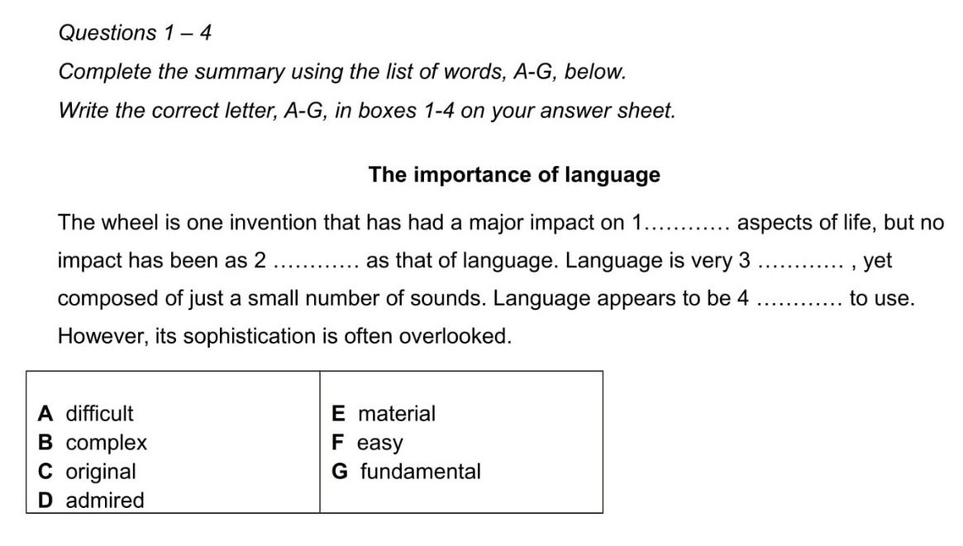
- The second format, short-answer question, requires finding the appropriate words from the passage to fill in the blanks in the summary. For this format, it is necessary to carefully check the exact number of words and/or numbers allowed in each blank.
number of words and/or numbers allowed in each blank.
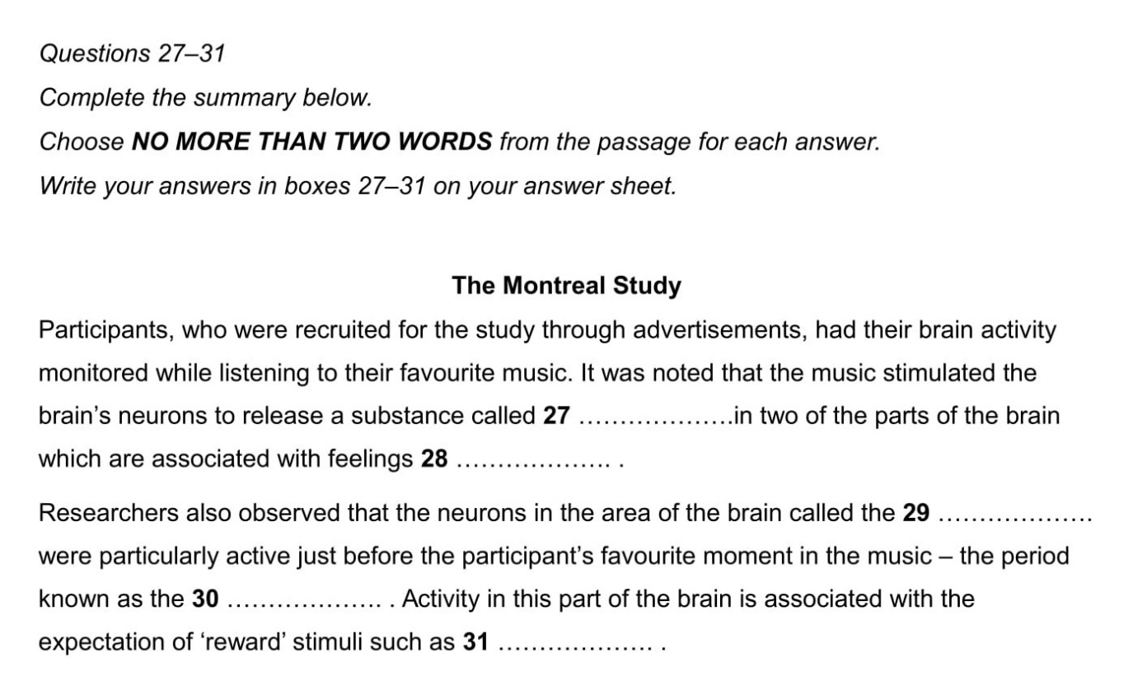
➤ Steps to Do the Task
STEP 1: Identify the main idea of the summary, find keywords and the content of the gap.
- Quickly check the title and content of the summary to grasp the overall topic.
- Identify the keywords and the main content of the gap.
- For the short-answer question format, determine the type of word needed (noun, verb, adjective, etc.).
STEP 2: Locate the relevant part in the passage that matches the identified keywords (apply the scanning technique).
STEP 3: Choose the correct answer to fill in the blank and check its accuracy.
- Select the most suitable answer and make sure the sentence is complete and consistent with the passage.
➤ Tips
- If the summary has no title, skim the whole passage to determine the basic idea.
- In the Summary Completion task, sometimes the words in the given list are not taken directly from the passage but are synonyms. Therefore, read all the words in the list carefully.

2. MATCHING FEATURES
➤ Steps to Do the Task
STEP 1: Read the instructions and identify keywords and the content of the given statements.
- Read the instructions carefully to understand the task requirements.
- Identify the keywords and the main idea of each given statement.
STEP 2: Locate the relevant information in the passage
- Use the scanning technique to find the part of the text related to the identified keywords.
STEP 3: Choose the correct answer
- From the list of options, select the name(s) or item(s) that appear in the section of the text you have found in Step 2 and match them with the given statement.
III. PRACTICE
You should spend about 20 minutes on Questions 1-13 which are based on Reading Passage 1 below.
Research using twins
To biomedical researchers all over the world, twins offer a precious opportunity to untangle the influence of genes and the environment – of nature and nurture. Because identical twins come from a single fertilized egg that splits into two, they share virtually the same genetic code. Any differences between them -one twin having younger looking skin, for example – must be due to environmental factors such as less time spent in the sun.
Alternatively, by comparing the experiences of identical twins with those of fraternal twins, who come from separate eggs and share on average half their DNA, researchers can quantify the extent to which our genes affect our lives. If identical twins are more similar to each other with respect to an ailment than fraternal twins are, then vulnerability to the disease must be rooted at least in part in heredity.
These two lines of research – studying the differences between identical twins to pinpoint the influence of environment, and comparing identical twins with fraternal ones to measure the role of inheritance – have been crucial to understanding the interplay of nature and nurture in determining our personalities, behavior, and vulnerability to disease.
The idea of using twins to measure the influence of heredity dates back to 1875, when the English scientist Francis Galton first suggested the approach (and coined the phrase ‘nature and nurture’). But twin studies took a surprising twist in the 1980s, with the arrival of studies into identical twins who had been separated at birth and reunited as adults. Over two decades 137 sets of twins eventually visited Thomas Bouchard’s lab in what became known as the Minnesota Study of Twins Reared Apart. Numerous tests were carried out on the twins, and they were each asked more than 15,000 questions.
Bouchard and his colleagues used this mountain of data to identify how far twins were affected by their genetic makeup. The key to their approach was a statistical concept called heritability. In broad terms, the heritability of a trait measures the extent to which differences among members of a population can be explained by differences in their genetics. And wherever Bouchard and other scientists looked, it seemed, they found the invisible hand of genetic influence helping to shape our lives.
Lately, however, twin studies have helped lead scientists to a radical new conclusion: that nature and nurture are not the only elemental forces at work. According to a recent field called epigenetics, there is a third factor also in play, one that in some cases serves as a bridge between the environment and our genes, and in others operates on its own to shape who we are.
Epigenetic processes are chemical reactions tied to neither nature nor nurture but representing what researchers have called a ‘third component’. These reactions influence how our genetic code is expressed: how each gene is strengthened or weakened, even turned on or off, to build our bones, brains and all the other parts of our bodies.
If you think of our DNA as an immense piano keyboard and our genes as the keys – each key symbolizing a segment of DNA responsible for a particular note, or trait, and all the keys combining to make us who we are – then epigenetic processes determine when and how each key can be struck, changing the tune being played.
One way the study of epigenetics is revolutionizing our understanding of biology is by revealing a mechanism by which the environment directly impacts on genes. Studies of animals, for example, have shown that when a rat experiences stress during pregnancy, it can cause epigenetic changes in a fetus that lead to behavioral problems as the rodent grows up. Other epigenetic processes appear to occur randomly, while others are normal, such as those that guide embryonic cells as they become heart, brain, or liver cells, for example.
Geneticist Danielle Reed has worked with many twins over the years and thought deeply about what twin studies have taught us. ‘It’s very clear when you look at twins that much of what they share is hardwired,’ she says. ‘Many things about them are absolutely the same and unalterable. But it’s also clear, when you get to know them, that other things about them are different. Epigenetics is the origin of a lot of those differences, in my view.’
Reed credits Thomas Bouchard’s work for today’s surge in twin studies. ‘He was the trailblazer,’ she says. ‘We forget that 50 years ago things like heart disease were thought to be caused entirely by lifestyle. Schizophrenia was thought to be due to poor mothering. Twin studies have allowed us to be more reflective about what people are actually born with and what’s caused by experience.’
Having said that, Reed adds, the latest work in epigenetics promises to take our understanding even further. ‘What I like to say is that nature writes some things in pencil and some things in pen,’ she says. ‘Things written in pen you can’t change. That’s DNA. But things written in pencil you can. That’s epigenetics. Now that we’re actually able to look at the DNA and see where the pencil writings are, it’s sort of a whole new world.’

Questions 1-4
Do the following statements agree with the information given in Reading Passage?
Shop for bestsellers
In boxes 1-4 on your answer sheet, write
TRUE if the statement agrees with the information
FALSE if the statement contradicts the information
NOT GIVEN if there is no information on this
1 There may be genetic causes for the differences in how young the skin of identical twins looks.
2 Twins are at greater risk of developing certain illnesses than non-twins.
3 Bouchard advertised in newspapers for twins who had been separated at birth.
4 Epigenetic processes are different from both genetic and environmental processes.

Questions 5-9
Look at the following statements (Questions 5-9) and the list of researchers below.
Match each statement with the correct researcher, A, B or C.
Write the correct letter, A, B or C, in boxes 5-9 on your answer sheet.
NB You may use any letter more than once.
List of Researchers
A Francis Galton
B Thomas Bouchard
C Danielie Reed
5 invented a term used to distinguish two factors affecting human characteristics
6 expressed the view that the study of epigenetics will increase our knowledge
7 developed a mathematical method of measuring genetic influences
8 pioneered research into genetics using twins
9 carried out research into twins who had lived apart

Questions 10-13
Complete the summary using the list of words, A-F, below.
Write the correct letter, A-F, in boxes 10-13 on your answer sheet.
Epigenetic processes
In epigenetic processes, 10……………. influence the activity of our genes, for example in creating our internal 11………….. The study of epigenetic processes is uncovering a way in which our genes can be affected by our 12……………. One example is that if a pregnant rat suffers stress, the new-born rat may later show problems in its 13……………….
A nurture B organs C code
D chemicals E environment F behaviour/behavior

